**Assignment-2 [Operators]**

[Submitted by **Malika Hafiza Pasha**]

**Please implement by using Python**

1. A. Write an equation which relates 399, 543 and 12345.

B. “When I divide 5 with 3, I got 1. But when I divide -5 with 3, I got -2”—How would you justify it.

**Answer:** [Python file is attached with the assignment file]

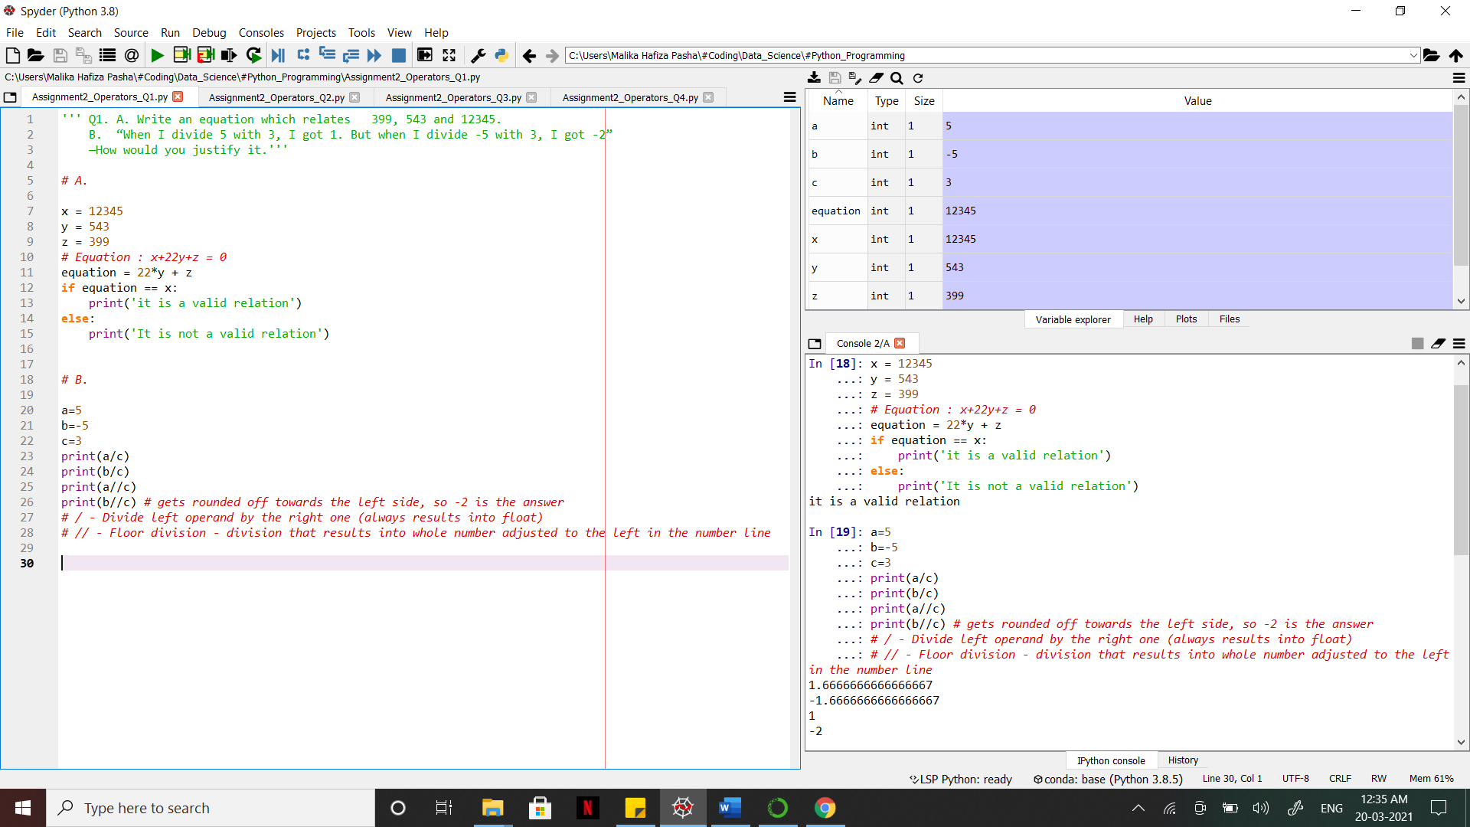

2. a=5, b=3, c=10. What will be the output of the following?

A. a/=b

B. c*=5

**Answer:** [Python file is attached with the assignment file]

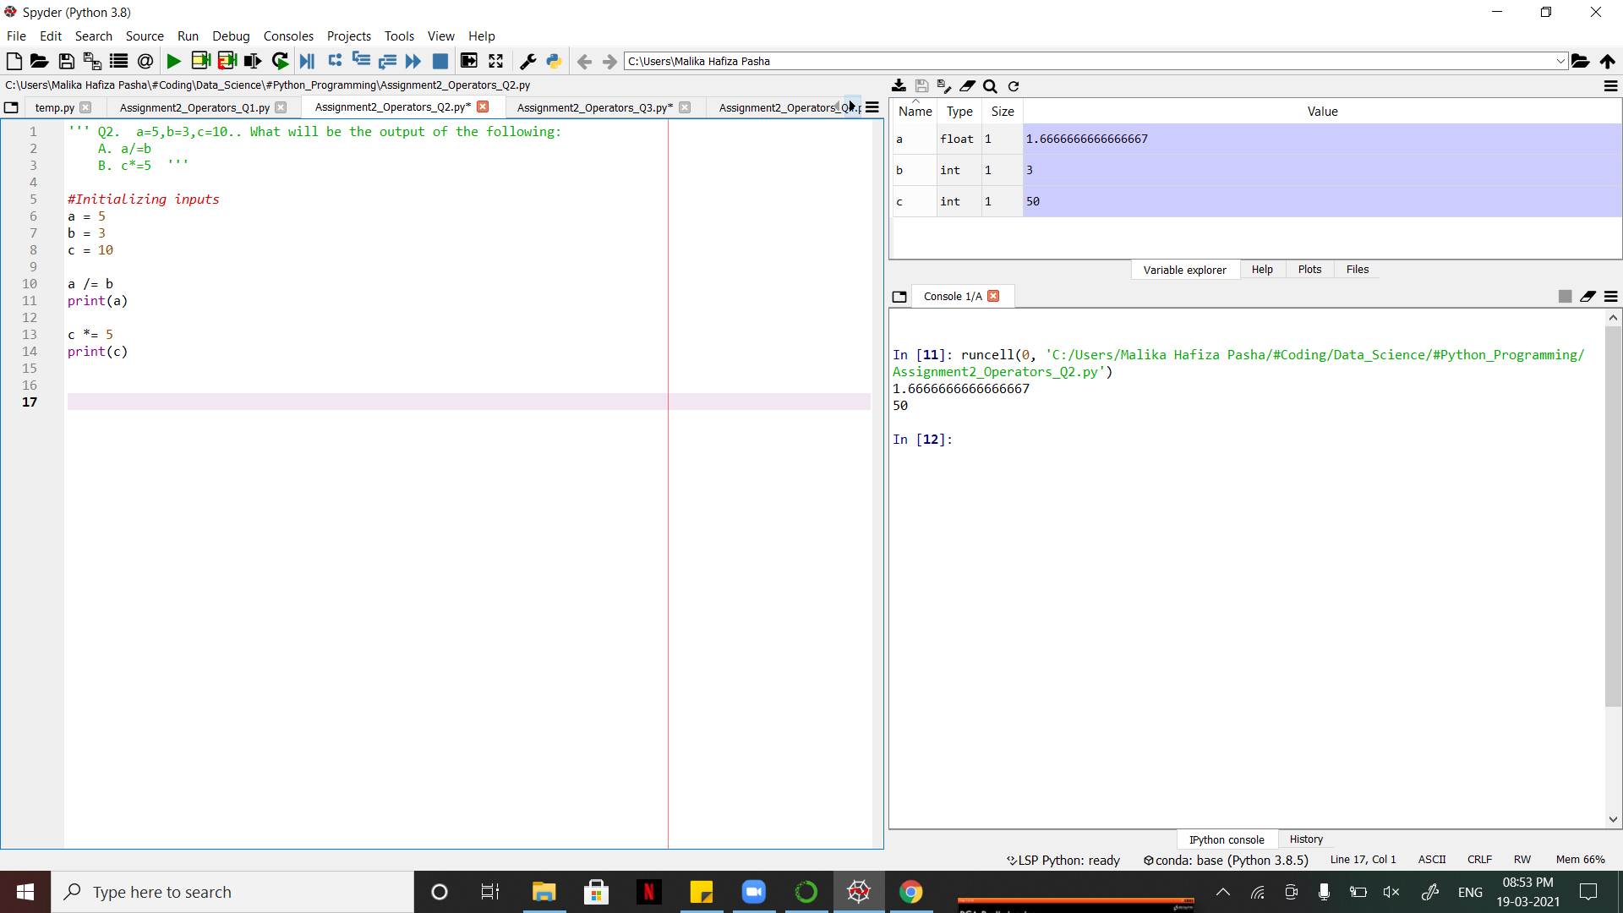

3. A. How can you print a number between 55 and 75?

B. How can you print a number which is either below 55 or above 75.

**Answer:** [Python file is attached with the assignment file]

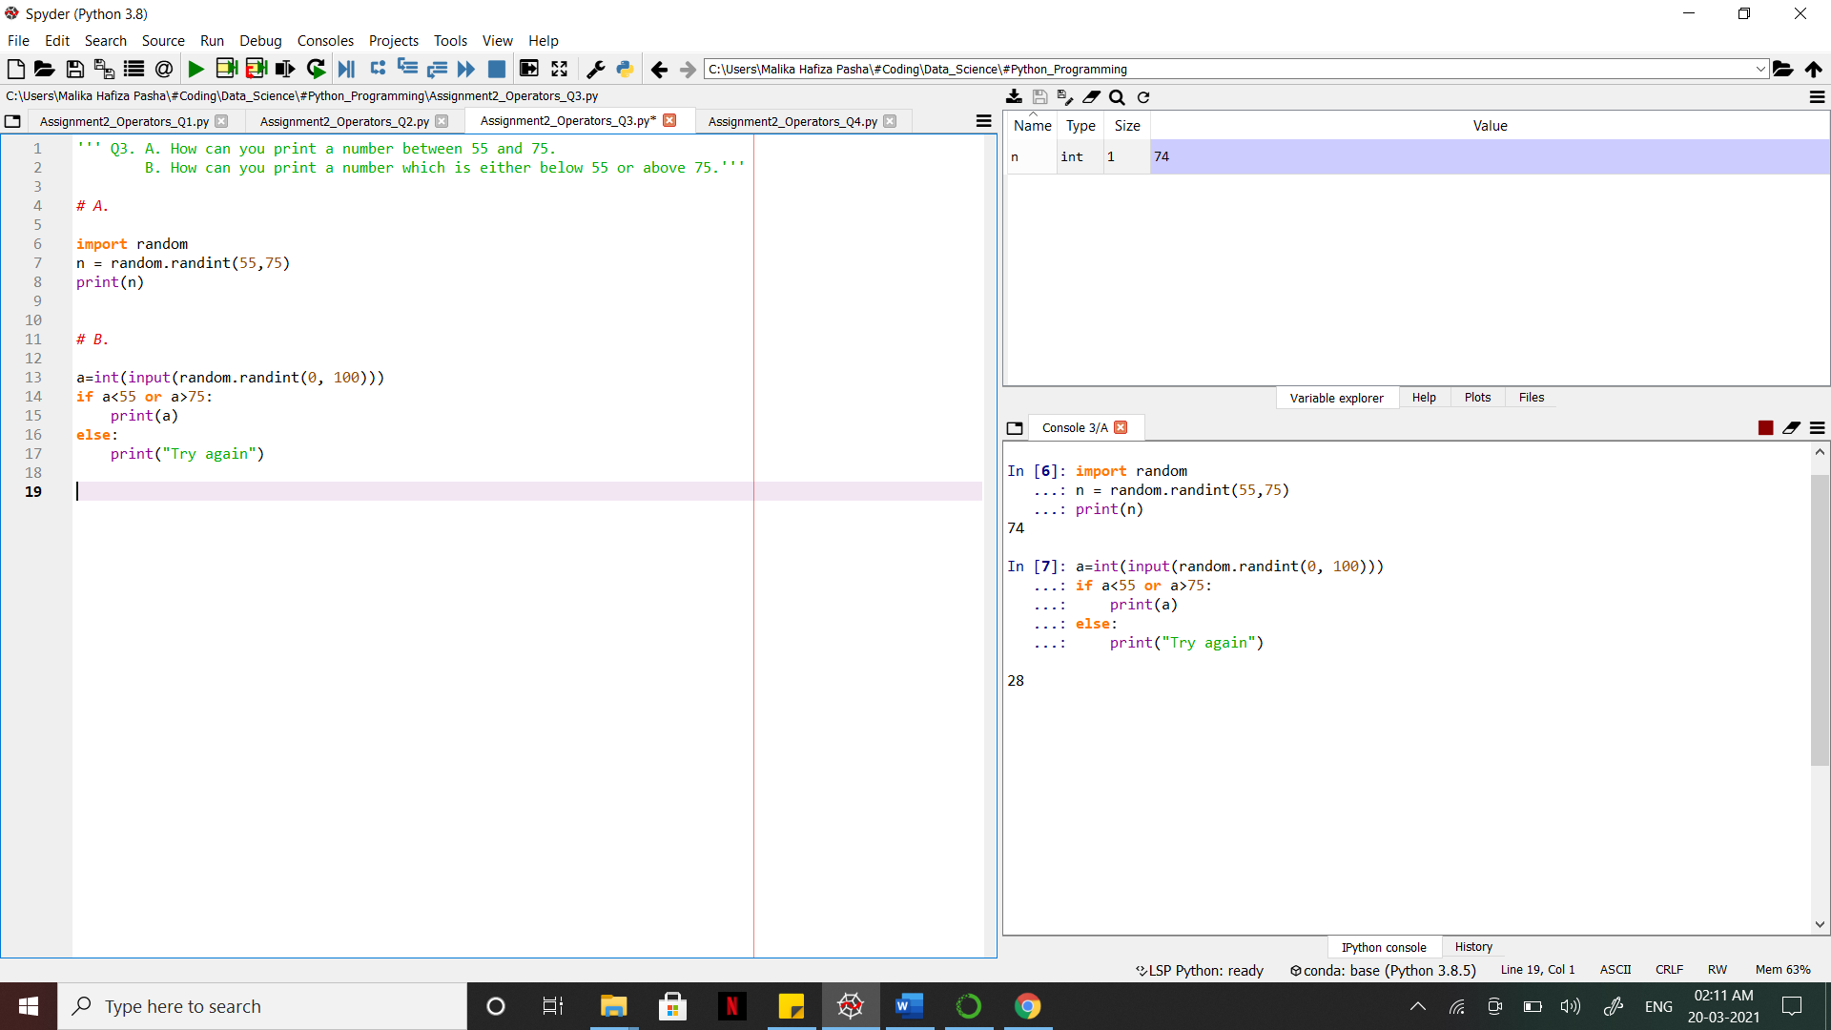

4. A. How to check the presence of an alphabet ‘s’ in word “Data Science”.

B. How can you obtain 64 by using numbers 4 and 3.

**Answer:** [Python file is attached with the assignment file]

